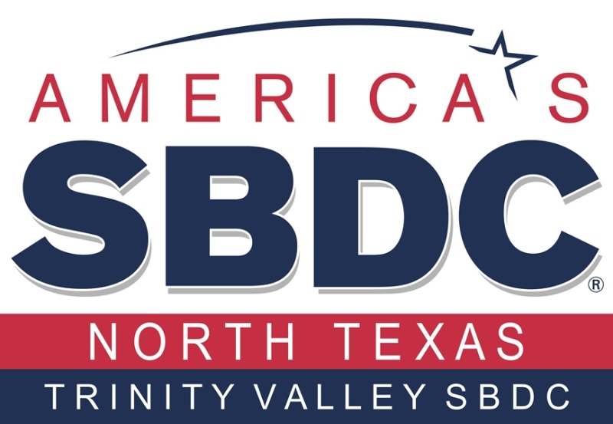
Trinity Valley Small Business Development Center
Client Needs Assessment
Trinity Valley SBDC provides business growth resources to local entrepreneurs, startups and existing business owners. Please complete this brief assessment form so we can refer you to the best tools to fit you needs.

First Name
_________________________

Last Name
_________________________

E-mail
_________________________

Phone Number (xxx-xxx-xxxx)
_________________________

Website Address (if any)
_________________________

Are you in business now or are you looking to start a business?
____ I am in business
____ I want to start a business
____ My business status is unclear

Does your home or business reside in one of the following counties?
____ Anderson ____ Henderson ____ Kaufman
____ Rains ____ Van Zandt ____ Other_______________

What city is your business now or likely to be located?

________________________________________________________________________________________

Briefly describe the type of business you are looking to start or grow.

________________________________________________________________________________________
________________________________________________________________________________________
________________________________________________________________________________________
________________________________________________________________________________________
________________________________________________________________________________________
________________________________________________________________________________________

How much money do you need to start or grow your business?

____ $0 - $1,000
____ $1,001 - $5,000
____ $5,001 - $10,000
____ $10,001 - $25,000
____ $25,001 - $50,000
____ $50,001 - $100,000
____ $100,001 - $250,000
____ More than $250,001
____ Unknown

How do you plan to finance the start-up or growth of your business? (Check all that apply)

____ Savings - how much? ______________________
____ Family and/or Friends
____ Investors
____ Bank term loan/line of credit
____ Retirement funds (i.e. 401K)

Do you have collateral that can be used to secure a loan if ever necessary?

____ Yes
____ No
____ I don’t know

What is your credit score? (Note: If you don’t know you might consider visiting www.creditkarma.com)

____ 750 or above
____ 700-750
____ 650-700
____ 600-650
____ Below 600
____ I don’t know

How soon are you looking to start or grow your business?

____ Less than 30 days
____ 1 to 3 months
____ 3 to 6 months
____ 6 to 12 months
____ 1 year +
____ Unknown

Please describe the areas of assistance you are seeking from the Trinity Valley SBDC to start or grow your business.

________________________________________________________________________________________________________________________________________________________________________________________________________________________________________________________________________________________________________________________________________________________________________
__________________________________________________________________________________________

How did you hear about the Trinity Valley SBDC?

____ Bank ____ Chamber ____ Client/Word of Mouth
____ County/City Government ____ Internet Search ____ College/University
____ Local Economic Development ____ SBA ____ SBDC
____ Training Seminar ____ SCORE ____ Social Media/Blog
____ Other _______________________

Have you ever received any business assistance from any of the following? (Check all that apply)

____ Trinity Valley SBDC
____ Dallas Metropolitan SBDC
____ Center for Government Contracting
____ International SBDC
____ SCORE
____ Independent Business Consultant
____ None
____ Other _____________________________

