Basic EKG Dysrhythmia Identification
by
Andrea Diane Posey, RN, MSN
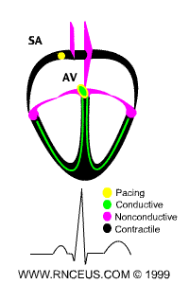
The content of this site is intended for use by individual nurses as continuing nursing education only.
This site is not to be used as a substitute for medical advice from a health care provider.
2002 © RnCeus Interactive,LLC all rights reserved

EKG Course Introduction

Course Overview: This course begins with a discussion of the physiology of cardiac conduction, and then covers the basics of how to read an EKG strip, and the normal components of the EKG waveform. We will then examine basic cardiac dysrhythmias, including atrial and ventricular dysrhythmias, and blocks. Finally, selected nursing diagnoses for patients with dysrhythmias will be offered, along with suggested associated nursing interventions. See Objectives for specific course goals.

Here are a few hints to help you navigate through the course.
- Click on links in the Table of Contents frame on the left side of the screen. You can view pages consecutively, or access any page at any time.
- Link to Rnceus Interactive e-mail or return to Rnceus Interactive Home Page from the Table of Contents.
- Access the Exam and Evaluation Form at the end of the course - or whenever you're ready. Follow instructions on that page to obtain RN contact hours, or to just try the questions.
- Links to the World Wide Web enrich the course content. Review the different sites and then click "BACK" on your browser to return to the course. Or "BOOKMARK" the site now for easy reference!
- Scattered throughout the course are Instant Feedback areas, like the one below. Review information about the Target Audience and give it a try!

Instant Feedback: To reinforce the material, quiz yourself on what you have learned while studying this information. Wherever you see this color text, questions are accessible.
For example:
The target audience for this course is health care professionals interested in learning more about EKG interpretation.
TRUE or FALSE

Course Objectives

Upon completion of this program the learner should be able to:
- Identify basic normal EKG waveform morphology.
- Describe the normal physiology of cardiac conduction.
- Distinguish between basic dysrhythmias.
- Describe the physiological consequences and treatments of these basic dysrhythmias.

Target Audience

- The target audience for this course is nurses and other health professionals who would like to learn, or review, basic EKG dysrhythmia identification.
- Nurses and other health professionals may earn 5.0 contact hours for completing this course.
  - To earn 5.0 contact hours, participants must agree to spend no less than 250 minutes studying course material, exploring Internet links, and completing exam and evaluation.

Literature Review

According to the current literature, there is firm support for nurses becoming competent in cardiac monitoring and dysrhythmia identification. According to Beery (1998), over the last few years nurses outside of critical care have been asked to take care of patients with cardiac dysrhythmias. These nurses need to have some basic education regarding the cardiac conditions of their patients. They must also have an understanding of the fundamentals of cardiac monitoring, and dysrhythmia interpretation. It is essential that institutions have emergency policies and procedures in place, along with a continuing competency education program and yearly refresher programs. The programs should include validation of dysrhythmia interpretation skills and problem solving of case studies.
Nurses have significant diagnostic influence in the areas of cardiac rhythm monitoring and dysrhythmia identification (Hebra, 1994). It is essential that nurses who care patients at risk for cardiac dysrhythmias have a thorough understanding of accurate electrode placement. They must also use current principles when determining the optimal leads to use in monitoring specific types of dysrhythmias.
EKG monitoring is becoming more common in both inpatient and outpatient care settings (Scrima, 1997). Nurses are asked to be responsible for cardiac patients, including monitoring and interpreting cardiac dysrhythmias. They must develop critical thinking skills that help them evaluate the significance of these dysrhythmias. A thorough understanding of cardiac anatomy, physiology and properties can provide a framework for understanding and interpreting cardiac rhythms.

Instant Feedback:
Nurses outside the critical care settings do not need to master EKG dysrhythmia interpretation.
TRUE or FALSE

Physiology of Cardiac Conduction

In an adult with a healthy heart, the heart rate is usually about 72 beats per minute.
The excitatory and electrical conduction system of the heart is responsible for the contraction and relaxation of the heart muscle. The sinoatrial node (SA node) is the pacemaker where the electrical impulse is generated. This node is located along the posterior wall of the right atrium right beneath the opening of the superior vena cava. It is crescent shaped and about 3 mm wide and 1 cm long.
The impulse travels from the SA node through the internodal pathways to the atrioventricular node (AV node). The AV node is responsible for conduction of the impulse from the atria to the ventricles. The impulse is delayed slightly at this point to allow complete emptying of the atria before the ventricles contract.The impulse continues through the AV bundle and down the left and right bundle branches of the Purkinje fibers. The Purkinje fibers conduct the impulse to all parts of the ventricles, causing contraction (Guyton, 1982).
Abnormal heart rhythms occur for several reasons.
- The vagal stimulation of the parasympathetic nervous system can cause a decrease in the rate at the SA node and can also decrease the excitability of the AV junction fibers. This causes a slowing of the heart rate, and in severe cases a complete blockage of the impulse through the AV junction.
- Sympathetic stimulation also effects cardiac rhythm and conduction. It increases the rate at the SA node and increases the rate of conduction and excitability throughout the heart. It also increases the force of myocardial contraction. Subsequently, the overall workload on the heart is increased.
- A small area of the heart can become more excitable than normal, which causes abnormal heart beats called ectopy. Ectopic foci are usually caused by an irritable area in the heart. This irritability can be caused by ischemia, stimulants such as nicotine and caffeine, lack of sleep or anxiety (Guyton, 1982).

Instant Feedback:
Parasympathetic stimulation of the heart can:
A. Increase the heart rate
B. Increase contractility of the heart
C. Decrease the heart rate

Please visit this "Cardiac Care" website for educational information about the heart geared towards patients/clients.

How to Read an EKG Strip

EKG paper is a grid where time is measured along the horizontal axis.
- Each small square is 1 mm in length and represents 0.04 seconds.
- Each larger square is 5 mm in length and represents 0.2 seconds.
Voltage is measured along the vertical axis.
- 10 mm is equal to 1mV in voltage.
- The diagram below illustrates the configuration of EKG graph paper and where to measure the components of the EKG wave form
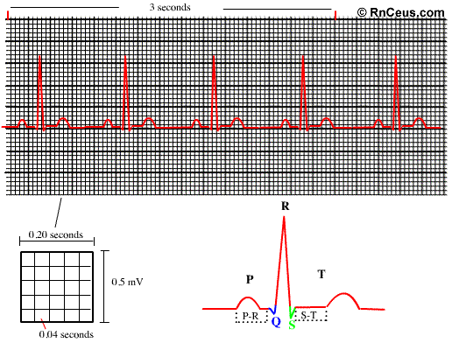
Heart rate can be easily calculated from the EKG strip:
- When the rhythm is regular, the heart rate is 300 divided by the number of large squares between the QRS complexes.
  - For example, if there are 4 large squares between regular QRS complexes, the heart rate is 75 (300/4=75).
- The second method can be used with an irregular rhythm to estimate the rate. Count the number of R waves in a 6 second strip and multiply by 10.
  - For example, if there are 7 R waves in a 6 second strip, the heart rate is 70 (7x10=70).

Instant Feedback:
On a typical EKG grid, 5 small squares, or 1 large square, represent 0.20 seconds of time
TRUE or FALSE

Normal Components of the EKG Waveform

P wave
- Indicates atrial depolarization, or contraction of the atrium.
- Normal duration is not longer than 0.11 seconds (less than 3 small squares)
- Amplitude (height) is no more than 3 mm
- No notching or peaking
QRS complex
- Indicates ventricular depolarization, or contraction of the ventricles.
- Normally not longer than .10 seconds in duration
- Amplitude is not less than 5 mm in lead II or 9 mm in V3 and V4
- R waves are deflected positively and the Q and S waves are negative
T wave
- Indicates ventricular repolarization
- Not more that 5 mm in amplitude in standard leads and 10 mm in precordial leads
- Rounded and asymmetrical
ST segment
- Indicates early ventricular repolarization
- Normally not depressed more than 0.5 mm
- May be elevated slightly in some leads (no more than 1 mm)
PR interval
- Indicates AV conduction time
- Duration time is 0.12 to 0.20 seconds
QT interval
- Indicates repolarization time
- General rule: duration is less than half the preceding R-R interval

Instant Feedback:
Normal QRS duration is 0.15 - 0.25 seconds.
TRUE or FALSE

The American Heart Association website is an excellent source of cardiac information.

Electrode Placement and Lead Selection

Proper electrode placement is essential in order to acquire accurate EKG strips. Most EKG monitor manufacturers have a set of placement guidelines specific to their products.
The following are some general guidelines.
- Skin preparation:
  - Shave hair away from electrode placement site.
  - Rub site briskly with alcohol pad.
  - Rub site with 2x2 gauze.
  - Place electrode. Be sure that the electrode has adequate gel and is not dry.
- 3 lead placement:
- Depolarization wave moving toward a positive lead will be upright.
- Depolarization wave moving toward a negative lead will inverted.
- Depolarization wave moving between negative and positive leads will have both upright and inverted components.
- Five lead placement allows viewing of all leads within the limits of the monitor.

Lead selection
- Lead II is the same as standard lead two as seen in a 12 lead EKG.
  - It is the most common monitoring lead.
  - It is not the optimal monitoring lead.
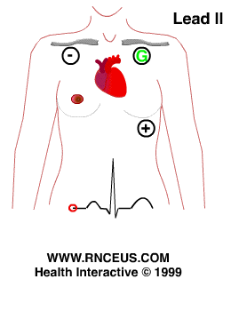
- V1 lead is the best lead to view ventricular activity and differentiate between right and left bundle branch blocks.
  - The only way to view V1 is with a five lead system.
  - Therefore, MCL1 was designed to overcome the inconvenience of a five lead system and provide all the advantages of V1 viewing.
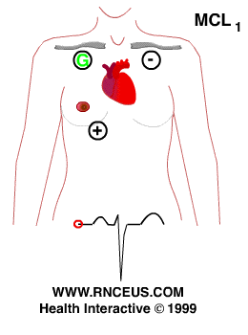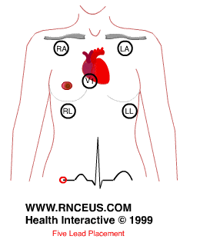
Trouble shooting and tips
- Change the electrodes everyday.
- Make sure all electrical patient care equipment is grounded.
- Be sure all the lead cables are intact. Some manufacturers require changing the cables periodically.
- Be sure the patient's skin is clean and dry.
- Make sure the leads are connected tightly to the electrodes.
- Patient movement frequently causes interference. For example, the action of brushing teeth may cause interference that mimics V-tach

Sinus Bradycardia

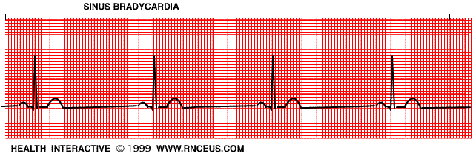
Rate | 40-59 bpm
P wave | sinus
QRS | normal (.06-.12)
Conduction | P-R normal or slightly prolonged at slower rates
Rhythm | regular or slightly irregular
This rhythm is often seen as a normal variation in athletes, during sleep, or in response to a vagal maneuver. If the bradycardia becomes slower than the SA node pacemaker, a junctional rhythm may occur.
Treatment includes:
- treat the underlying cause,
- atropine,
- isuprel, or
- artificial pacing if patient is hemodynamically compromised.

Instant Feedback:
Sinus bradycardia is always abnormal and must be treated.
TRUE or FALSE

Sinus Tachycardia

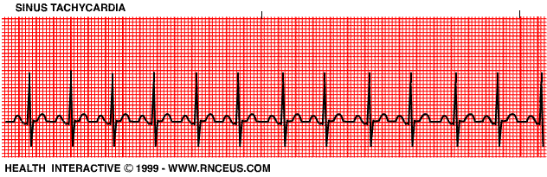

Rate | 101-160/min
P wave | sinus
QRS | normal
Conduction | normal
Rhythm | regular or slightly irregular
The clinical significance of this dysrhythmia depends on the underlying cause. It may be normal.
Underlying causes include:
- increased circulating catecholamines
- CHF
- hypoxia
- PE
- increased temperature
- stress
- response to pain
Treatment includes identification of the underlying cause and correction.

Instant Feedback:
Sinus tachycardia is a normal response to pain.
TRUE or FALSE

Sinus Arrhythmia

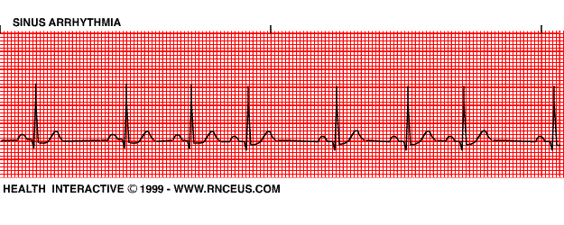
Rate | 45-100/bpm
P wave | sinus
QRS | normal
Conduction | normal
Rhythm | regularly irregular
The rate usually increases with inspiration and decreases with expiration.
This rhythm is most commonly seen with respiration due to fluctuations in vagal tone.
The non respiratory form is present in diseased hearts and sometimes confused with sinus arrest (also known as "sinus pause").
Treatment is not usually required unless symptomatic bradycardia is present.

Wandering Atrial Pacemaker

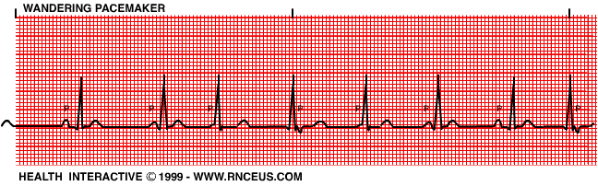
Rate | variable depending on the site of the pacemaker; usually 45-100/ bpm.
P wave | also variable in morphology
QRS | normal
Conduction | P-R interval varies depending on the site of the pacemaker
Rhythm | irregular
This dysrhythmia may occur in normal hearts as a result of fluctuations in vagal tone. It may also be seen in patients with heart disease or COPD.
Wandering atrial pacemaker may also be a precursor to multifocal atrial tachycardia.
There is usually no treatment required.

Premature Atrial Contractions

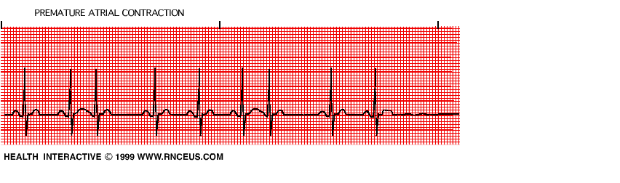
Rate | normal or accelerated
P wave | usually have a different morphology than sinus P waves because they originate from an ectopic pacemaker
QRS | normal
Conduction | normal, however the ectopic beats may have a different P-R interval.
Rhythm | PAC's occur early in the cycle and they usually do not have a complete compensatory pause.
PAC's occur normally in a non diseased heart.
- However, if they occur frequently, they may lead to a more serious atrial dysrhythmias.
- They can also result from CHF, ischemia and COPD.

Instant Feedback:
With PACs, all the P waves look identical.
TRUE or FALSE

Sinus Arrest

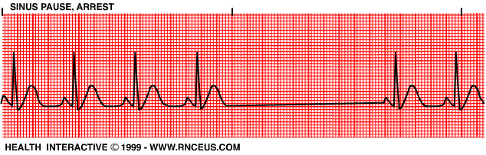
Rate | normal
P wave | those that are present are normal
QRS | normal
Conduction | normal
Rhythm | The basic rhythm is regular. The length of the pause is not a multiple of the sinus interval.
This may occur in individuals with healthy hearts. It may also occur with increased vagal tone, myocarditis, MI, and digitalis toxicity.
If the pause is prolonged, escape beats may occur.
The treatment of this dysrhythmia depends on the underlying cause.
- If the cause is due to increased vagal tone and the patient is symptomatic, atropine may be indicated.

Instant Feedback:
Atropine should never be used to treat sinus arrest.
TRUE or FALSE

Sinoatrial Block

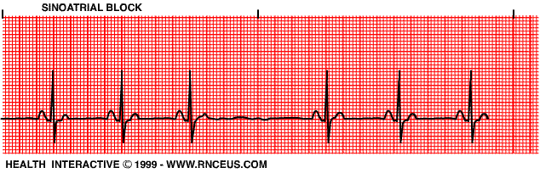
Rate | normal or bradycardia
P wave | those present are normal
QRS | normal
Conduction | normal
Rhythm | basic rhythm is regular*.
*In a type I SA block, the P-P interval shortens until one P wave is dropped.
*In a type II SA block, the P-P intervals are an exact multiple of the sinus cycle, and are regular before and after the dropped P wave.
This usually occurs transiently and produces no symptoms. It may occur in healthy patients with increased vagal tone. It may also be found with CAD, inferior MI, and digitalis toxicity.

Multifocal Atrial Tachycardia

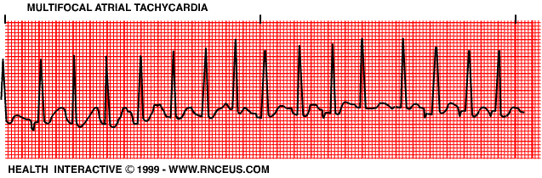
Rate | 100-250/bpm
P wave | two or more ectopic P waves with different morphologies
QRS | normal
Conduction | P-R intervals vary
Rhythm | irregular
Multifocal atrial tachycardia (MAT) may resemble atrial fibrillation or flutter.
It almost always occurs in seriously ill, elderly individuals.COPD is the most common underlying cause.
Treatment depends upon the underlying cause.

Instant Feedback:
In MAT, all P waves are identical in morphology, and P-R intervals are constant
TRUE or FALSE

Multifocal Atrial Tachycardia

Rate | 100-250/bpm
P wave | two or more ectopic P waves with different morphologies
QRS | normal
Conduction | P-R intervals vary
Rhythm | irregular
Multifocal atrial tachycardia (MAT) may resemble atrial fibrillation or flutter.
It almost always occurs in seriously ill, elderly individuals.COPD is the most common underlying cause.
Treatment depends upon the underlying cause.

Instant Feedback:
In MAT, all P waves are identical in morphology, and P-R intervals are constant
TRUE or FALSE

Atrial Flutter

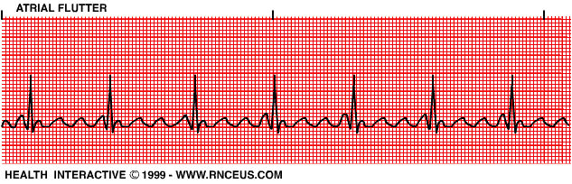
Rate | atrial 250-350/min; ventricular conduction depends on the capability of the AV junction (usually rate of 150-175 bpm).
P wave | not present; usually a "saw tooth" pattern is present.
QRS | normal
Conduction | 2:1 atrial to ventricular most common.
Rhythm | usually regular, but can be irregular if the AV block varies.
Atrial flutter almost always occurs in diseased hearts. It frequently precipitates CHF.
The treatment depends on the level of hemodynamic compromise.
- Cardioversion, vagal maneuvers and verapamil are used when prompt rate reduction is needed.
- Otherwise, digoxin and other antiarrhythmic drugs can be used.

Instant Feedback:
In atrial flutter, instead of P waves there is commonly a "sawtooth" pattern seen.
TRUE or FALSE

Atrial Fibrillation

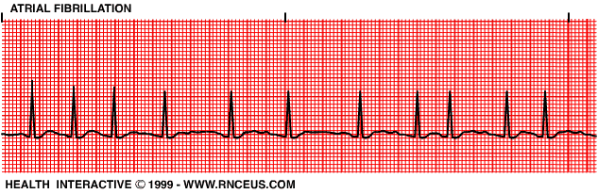
Rate | atrial rate usually between 400-650/bpm.
P wave | not present; wavy baseline is seen instead.
QRS | normal
Conduction | variable AV conduction; if untreated the ventricular response is usually rapid.
Rhythm | irregularly irregular. (This is the hallmark of this dysrhythmia).
Atrial fibrillation may occur paroxysmally, but it often becomes chronic. It is usually associated with COPD, CHF or other heart disease.
Treatment includes:
- Digoxin to slow the AV conduction rate.
- Cardioversion may also be necessary to terminate this rhythm.

Instant Feedback:
The hallmark sign of atrial fibrillation is:
A. A sawtooth pattern
B. An irregularly irregular rhythm
C. A compensatory pause

Please visit Virtual Hospitals site on cardiac arrhythmias.

Premature Junctional Contractions

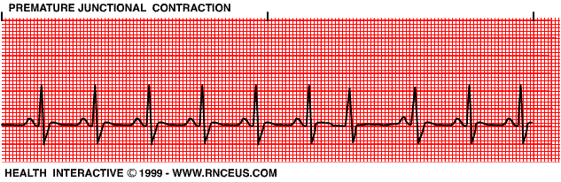
Rate | normal or accelerated.
P wave | as with junctional rhythm.
QRS | normal
Conduction | P-R interval < .12 secs if P waves are present.
Rhythm | PJC's occur early in the cycle of the baseline rhythm. A full compensatory pause may occur.
PJCs may occur in both healthy and diseased hearts. If they are occasional, they are insignificant. If they are frequent, junctional tachycardia may result.
Treatment is usually not required.

Junctional Tachycardia

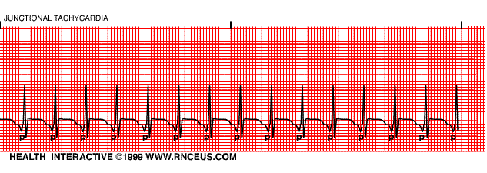
Rate | faster than 60/bpm
P wave | as with junctional rhythm.
QRS | normal or widened with aberrant ventricular conduction.
Conduction | P-R interval usually < .12 seconds if present
Rhythm | usually regular
The clinical significance of this rhythm depends upon the basic rhythm disturbance. If the ventricular rate is rapid, cardiac output may decrease.
Treatment includes:
- finding and correcting the underlying cause,
- vagal maneuvers,
- verapamil, and
- cardioversion.

Junctional Escape Beats and Rhythm

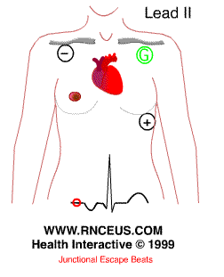
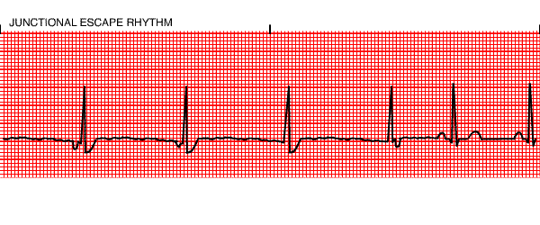
Rate | 40-60/bpm
P wave | inverted in leads where they are normally upright; this happens when the atrial depolarization wave moves towards a negative (-) lead. See diagram above. P waves may occur before, during or after the QRS, depending on where the pacemaker is located in the AV junction.
QRS | normal
Conduction | P-R interval < .12 seconds if present.
Rhythm | irregular as a result of the escape beats.
The most common cause of this rhythm in healthy individuals is sinus bradycardia.
It may also be seen in the presence of a high degree or complete AV block. If the ventricular rate is slow, hemodynamic compromise may occur.
Treatment depends upon the underlying cause and the baseline dysrhythmias.
- Atropine or a pacemaker may be used to increase the ventricular rate.

Instant Feedback:
With a junctional rhythm, P waves are inverted in leads where they are usually upright.
TRUE or FALSE

First Degree AV Block

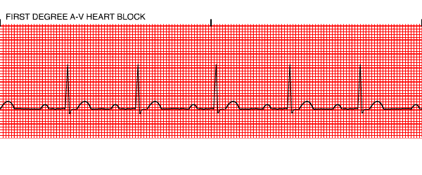
Rate | variable
P wave | normal
QRS | normal
Conduction | impulse originates in the SA node but has prolonged conduction in the AV junction; P-R interval is > 0.20 seconds.
Rhythm | regular
This is the most common conduction disturbance. It occurs in both healthy and diseased hearts.
First degree AV block can be due to:
- inferior MI,
- digitalis toxicity
- hyperkalemia
- increased vagal tone
- acute rheumatic fever
- myocarditis.
Interventions include treating the underlying cause and observing for progression to a more advanced AV block.

Instant Feedback:
In first degree AV block, the P-R interval is:
a. less than 0.12 seconds
b. between 0.12 and 0.18 seconds
c. greater than 0.20 seconds

Second Degree AV Block (Mobitz type I, Wenkebach)

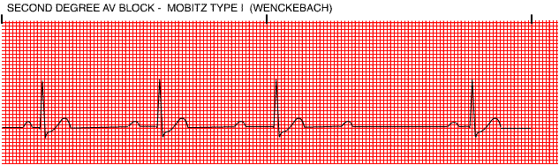[Image]
Rate | variable
P wave | normal morphology with constant P-P interval
QRS | normal
Conduction | the P-R interval is progressively longer until one P wave is blocked; the cycle begins again following the blocked P wave.
Rhythm | irregular
Second degree AV block type I occurs in the AV node above the Bundle of His.
It is often transient and may be due to acute inferior MI or digitalis toxicity.
Treatment is usually not indicated as this rhythm usually produces no symptoms.

Instant Feedback:
The Mobitz type I second degree AV block usually does not require any treatment.
TRUE or FALSE

Second Degree AV Block (Mobitz type II)

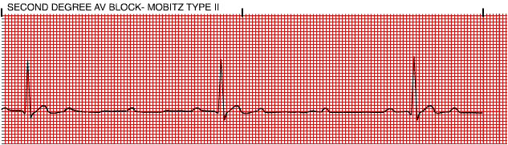
Rate | variable
P wave | normal with constant P-P intervals
QRS | usually widened because this is usually associated with a bundle branch block.
Conduction | P-R interval may be normal or prolonged, but it is constant until one P wave is not conducted to the ventricles.
Rhythm | usually regular when AV conduction ratios are constant
This block usually occurs below the Bundle of His and may progress into a higher degree block.
It can occur after an acute anterior MI due to damage in the bifurcation or the bundle branches.
It is more serious than the type I block.
Treatment is usually artificial pacing.

Third Degree AV Block or Complete AV Block

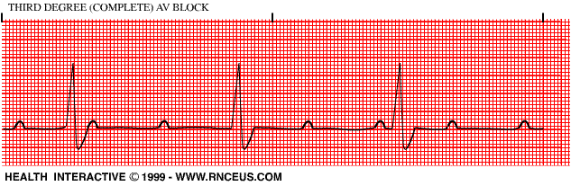
Rate | atrial rate is usually normal; ventricular rate is usually less than 70/bpm. The atrial rate is always faster than the ventricular rate.
P wave | normal with constant P-P intervals, but not "married" to the QRS complexes.
QRS | may be normal or widened depending on where the escape pacemaker is located in the conduction system
Conduction | atrial and ventricular activities are unrelated due to the complete blocking of the atrial impulses to the ventricles.
Rhythm | irregular
Complete block of the atrial impulses occurs at the A-V junction, common bundle or bilateral bundle branches.
Another pacemaker distal to the block takes over in order to activate the ventricles or ventricular standstill will occur.
May be caused by:
- digitalis toxicity
- acute infection
- MI and
- degeneration of the conductive tissue.
Treatment modalities include:
- external pacing and atropine for acute, symptomatic episodes and
- permanent pacing for chronic complete heart block.

Instant Feedback:
In a third degree heart block, the P waves are "married" to the QRS complexes.
TRUE or FALSE

Bundle Branch Block

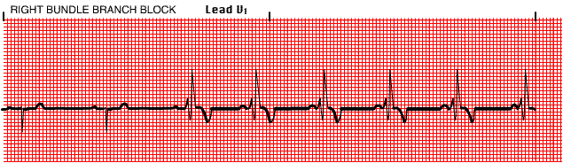
Rate | variable
P wave | normal if the underlying rhythm is sinus
QRS | wide; > 0.12 seconds
Conduction | This block occurs in the right or left bundle branches or in both. The ventricle that is supplied by the blocked bundle is depolarized abnormally.
Rhythm | regular or irregular depending on the underlying rhythm.
Left bundle branch block is more ominous than right bundle branch block because it usually is present in diseased hearts. Both may be caused by hypertension, MI, or cardiomyopathy. A bifasicular block may progress to third degree heart block.
Treatment is artificial pacing for a bifasicular block that is associated with an acute MI.

Premature Ventricular Contractions

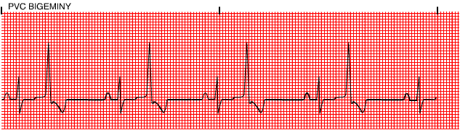
Rate | variable
P wave | usually obscured by the QRS, PST or T wave of the PVC
QRS | wide > 0.12 seconds; morphology is bizarre with the ST segment and the T wave opposite in polarity. May be multifocal and exhibit different morphologies.
Conduction | the impulse originates below the branching portion of the Bundle of His; full compensatory pause is characteristic.
Rhythm | irregular. PVC's may occur in singles, couplets or triplets; or in bigeminy, trigeminy or quadrigeminy.

PVCs can occur in healthy hearts. For example, an increase in circulating catecholamines can cause PVCs. They also occur in diseased hearts and from drug (such as digitalis) toxicities.
Treatment is required if they are:
- associated with an acute MI,
- occur as couplets, bigeminy or trigeminy,
- are multifocal, or
- are frequent (>6/min).
Interventions include:
- lidocaine,
- pronestyl, or
- quinidine.

Instant Feedback:
Treatment is usually required if there are more than six PVCs per minute.
TRUE or FALSE

Ventricular Tachycardia

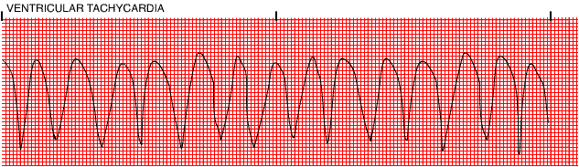
Rate | usually between 100 to 220/bpm, but can be as rapid as 250/bpm
P wave | obscured if present and are unrelated to the QRS complexes.
QRS | wide and bizarre morphology
Conduction | as with PVCs
Rhythm | three or more ventricular beats in a row; may be regular or irregular.
Ventricular tachycardia almost always occurs in diseased hearts.
Some common causes are:
- CAD
- acute MI
- digitalis toxicity
- CHF
- ventricular aneurysms.
Patients are often symptomatic with this dysrhythmia.
Ventricular tachycardia can quickly deteriorate into ventricular fibrillation.
- Electrical countershock is the intervention of choice if the patient is symptomatic and rapidly deteriorating.
- Some pharmacological interventions include lidocaine, pronestyl, and bretylium.

Instant Feedback:
Ventricular tachycardia is characterized by:
A. 3 or more PVCs in a row
B. A rate of 100-220 bpm
C. Wide and bizarre QRS complexes
D. All of the above
Torsade de Pointes

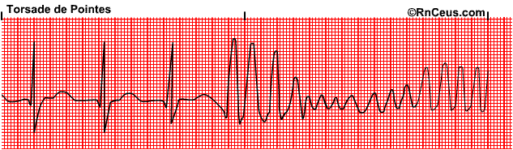
Rate | usually between 150 to 220/bpm,
P wave | obscured if present
QRS | wide and bizarre morphology
Conduction | as with PVCs
Rhythm | Irregular

Paroxysmal –starting and stopping suddenly
Hallmark of this rhythm is the upward and downward deflection of the QRS complexes around the baseline. The term Torsade de Pointes means "twisting about the points."
Consider it V-tach if it doesn’t respond to antiarrythmic therapy or treatments
Caused by:
- drugs which lengthen the QT interval such as quinidine
- electrolyte imbalances, particularly hypokalemia
- myocardial ischemia
Treatment:
- Synchronized cardioversion is indicated when the patient is unstable.
- IV magnesium
- IV Potassium to correct an electrolyte imbalance
- Overdrive pacing

For more information about Torsade, please click here and visit the emedicine site for an article by Dr. Bessette.

Ventricular Fibrillation

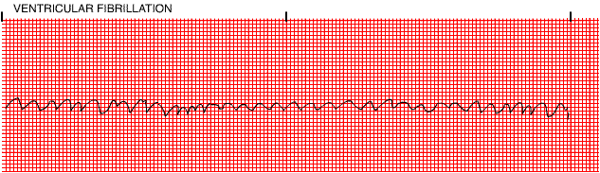
Rate | unattainable
P wave | may be present, but obscured by ventricular waves
QRS | not apparent
Conduction | chaotic electrical activity
Rhythm | chaotic electrical activity
This dysrhythmia results in the absence of cardiac output.
Almost always occurs with serious heart disease, especially acute MI.
The course of treatment for ventricular fibrillation includes:
- immediate defibrillation and ACLS protocols.
- Identification and treatment of the underlying cause is also needed.
Idioventricular Rhythm

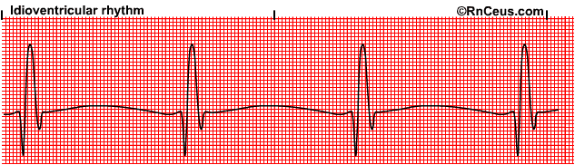
Rate | 20 to 40 beats per minute
P wave | Absent
QRS | Widened
Conduction | Failure of primary pacemaker
Rhythm | Regular
Absent P wave
Widened QRS > 0.12 sec.
Also called " dying heart" rhythm
Pacemaker will most likely be needed to re-establish a normal heart rate.
Causes:
- Myocardial Infarction
- Pacemaker Failure
- Metabolic imbalance
- Myoardial Ischemia
Treatment goals include measures to improve cardiac output and establish a normal rhythm and rate.
Options include:
- Atropine
- Pacing
Caution: Supressing the ventricular rhythm is contraindicated because that rhythm protects the heart from complete standstill

Asystole/Ventricular Standstill

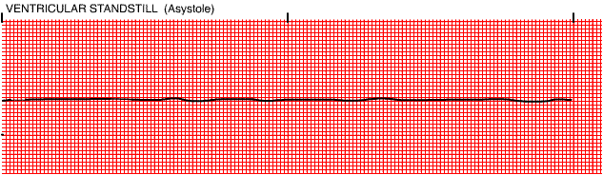
Rate | none
P wave | may be seen, but there is no ventricular response
QRS | none
Conduction | none
Rhythm | none
Asystole occurs most commonly following the termination of atrial, AV junctional or ventricular tachycardias. This pause is usually insignificant.
Asystole of longer duration in the presence of acute MI and CAD is frequently fatal.
Interventions include:
- CPR,
- artificial pacing, and
- atropine

Artifact

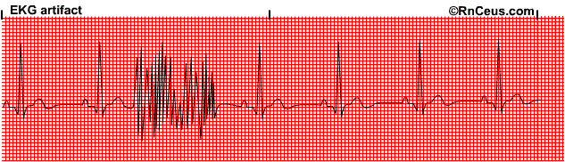
Artifact occurs when something causes a disruption in monitoring.
Some common causes are:
- AC interference -causes 60 cycle artifact
- Muscle tremors
- Respiratory artifact-wandering baseline
- Loose electrode
- Broken lead wire

Selected Nursing Diagnoses and Interventions for Patients with Dysrhythmias

•Alteration in cardiac output (decreased): In the case of dysrhythmias, decreased cardiac output is due to changes in heart rate, rhythm and conduction. This ultimately effects the mechanical function of the heart.
Nursing Interventions:
- Assess the patient for the underlying cause and contributing factors.
- Assess the patient for signs and symptoms of impending failure. This includes physical assessment, review of lab values, patient history and invasive hemodynamic parameters if available.
- Correct the underlying cause. This may include reduction of pain and anxiety, fluid restriction, fluid replacement, restricting activities that precipitate dysrhythmias. (e.g.valsalva) or placing the patient on oxygen.
- Maintain patency of all IV and other invasive lines.
- Provide psychosocial support for patient and family members.
- Promote adequate rest.
- Maintain appropriate nutritional and fluid balances.
- Patient teaching: includes acute activities such as reporting chest pain or dyspnea and wellness teaching such as stop smoking, stress reduction, weight reduction, heart healthy diet, drug regimen, and relaxation. Other patient teaching activities include teaching the patient home blood pressure, pulse and weight monitoring.
•Alteration in tissue perfusion (cardiopulmonary): Decreased tissue perfusion that is associated with dysrhythmias is probably due to decreased cardiac output
Nursing Interventions:
- Assess the patient for causative factors. In the case of dysrhythmias, this would entail identifying the dysrhythmia and determining if it was causing a decrease in tissue perfusion.
- Assess the patient for alteration in mentation, vital signs, postural blood pressure and signs of pulmonary emboli.
- Assess baseline labs: ABGs, electrolytes, BUN/creatinine, cardiac profile.
- Document and report chest pain, noting precipitating factors.
- Encourage restful atmosphere.
- Teach patient to decrease cardiac workload.
- Administer cardiac medications.
- Teach patient to self administer medications.
- Discuss necessary lifestyle changes such as stop smoking, diet, weight loss, appropriate exercises, and stress reduction.

Apply the knowledge that you now have after taking this basic course by taking an intermediate level course "Cardiac Case Studies: Apply Your Knowledge". You can refer back to this course for basic information as you take the case study course.

Still interested? Two more excellent websites
- An EKG tutorial (from Tasmania)
- This website has another tutorial, plus many EKG resources to investigate. (some links may be broken or disappointing, but we continue to include this link for it's wealth of true resources)

