TRINITY VALLEY COMMUNITY COLLEGE
HEALTH SCIENCE CENTER

GENERAL INFORMATION/POLICIES

BUILDING USAGE RULES
- Usual operating hours are from 0730-1700 Mondays through Fridays except in the summer when the building open from 0730 -1630 Mondays through Thursdays. Please watch for notice of time changes.

- Tobacco products are not permitted on campus (including e-cigarettes). This includes the building and grounds. Students may use e-cigarettes in their cars. Students are encouraged to visit the counselor for assistance with smoking cessation.

- Water bottles are allowed in class (except during tests and not while seated near TVCC computers). All other food and drinks are to be used only in the student lounge, except during approved events. During class time, students should put names on their drink containers and leave them on the counter in the student lounge and not in the hallway outside the classroom or auditorium. Students are responsible for cleaning up their own dirty dishes and making sure the coffeepot is turned off after use.

- Students should notify staff/faculty of any malfunctioning equipment.

- A copy machine is available in the library at 5 cents a copy. Please pay upon completion. Printing from the media center computers costs $0.05 per page. Students may not print on TVCC computers in Class A.

- Classroom/auditorium doors will be kept shut and locked when class is in session for safety reasons. Students who arrive late must wait until the next break. Students who have to leave class for any reason must wait until the next break to return.

- Please inform family/friends to call the Health Science Center (HSC) only in case of emergency.

- Notify office staff of any changes in name, address, e-mail address, and/or phone number.

- Children are not allowed at the HSC while the student is in class/skills or viewing audiovisuals.

- All electronic devices must be silenced (not on vibrate) during class and skills. They are distracting.

- Students using laptops during class should take care that their cords do not pose a safety hazard.

- To maintain confidentiality, students are asked not to loiter in hallway by faculty offices.

- Students at distance learning sites (Athens & Classroom A) are expected to follow the building usage rules of those facilities and the general rules of the auditorium. This includes not entering the class until break if late or not re-entering the classroom until break if they left for any reason.

TORNADOES
In case of a tornado warning, persons shall be directed to take the following safety precautions:
- take shelter immediately indoors;
- close all windows and doors;
- seek refuge in a small room with no windows such as a closet or bathroom, or take cover under heavy furniture in a central room of the structure, or in a hallway away from any doors or windows. Sit with back against the wall and with knees drawn into chest.

FIRE DRILL
Fire drills may be held at any time during the semester. When you hear the fire alarm, initiate the evacuation procedure. All persons should exit the building safely, without running or crowding, to designated areas using the nearest fire exit. The elevator may not be used. When a person in the front of the line finds a blocked exit, he/she should raise his/her right hand as a signal for the line to reverse directions and proceed out of the building through the nearest exit.
Transition/Sophomore Grassy area in front of hospital ER
Vocational/Staff/Test-takers/Guests By the HSC mailbox at top of hill
Surg Tech/ PCT/EMT Near the gazebo between hospital and HSC
Freshmen At far southeast corner of east student parking lot
When everyone in your class is out each lead instructor should raise his/her hand. When everyone has evacuated the building and been accounted for, instructions will be given for return. Please wait until notified.

HOW TO RESPOND WHEN AN ACTIVE SHOOTER IS IN YOUR VICINITY

Quickly determine the most reasonable way to protect your own life.

Evacuate

If there is an accessible escape path, attempt to evacuate the premises. Be sure to:

Have an escape route and plan in mind

Evacuate regardless of whether others agree to follow

Leave your belongings behind

Help others escape, if possible

Prevent individuals from entering an area where the active shooter may be

Keep your hands visible

Follow the instructions of any police officers

Do not attempt to move wounded people

Call 911 when you are safe

Hide out

If evacuation is not possible, find a place to hide where the active shooter is less likely to find you.

Your hiding place should:

Be out of the active shooter’s view

Provide protection if shots are fired in your direction (i.e., an office with a closed and locked door)

Not trap you or restrict your options for movement

To prevent an active shooter from entering your hiding place:

Lock the door

Blockade the door with heavy furniture

If the active shooter is nearby:

Lock the door

Silence your cell phone and/or pager

Turn off any source of noise (i.e., radios, televisions)

Hide behind large items (i.e., cabinets, desks)

Remain quiet

If evacuation and hiding out are not possible:

Remain calm

Dial 911, if possible, to alert police to the active shooter’s location

If you cannot speak, leave the line open and allow the dispatcher to listen

Take action against the active shooter

As a last resort, and only when your life is in imminent danger, attempt to disrupt and/or incapacitate the active shooter by:

Acting as aggressively as possible against him/her

Throwing items and improvising weapons

Yelling

Committing to your actions

How to react when law enforcement arrives

Remain calm, and follow officers’ instructions

Put down any items in your hands (i.e., bags, jackets)

Immediately raise hands and spread fingers

Keep hands visible at all times

Avoid making quick movements toward officers such as holding on to them for safety

Avoid pointing, screaming and/or yelling

Do not stop to ask officers for help or direction when evacuating, just proceed in the direction from which officers are entering the premises

PARKING
TVCC parking decals are required to park on campus. Please obey the TVCC parking policies. See figure below for student parking areas. There are 8 parking spaces marked in yellow that are reserved for high occupancy vehicles on Mondays and Tuesdays (HOV) (with car pools of 3 or more students). Make sure the names of the students are visible on the vehicle’s dashboard. On Mondays and Tuesdays, a shuttle will run from the HSC to the Country Bible Church at 401 N. Shannon St., a block north of the Health Science Center. The shuttle will start at 07:30. Students will be given a phone number to call for a ride and to schedule a ride back after class or at lunch. Do not park in faculty parking (green areas), hospital employee or physician parking. Violations can lead to a parking fine that must be paid, or the student can be prevented from future registration. When parking at clinical facilities, please check with assigned instructor and/or facility before clinical starts as to the parking regulations. Whenever there is a helicopter about to land, the hospital operators will make the announcement so that students/staff can move their vehicles should they choose. The gates around the helipad will be secured from before landing to takeoff. Students must not open the gates for liability and safety reasons. Do not drive on the grass to create a new exit from the parking lot. There are utilities which are buried in the ground and the weight of cars driving over them could break the pipes. Be sure to follow the city “No Parking” signs on Shannon Street.

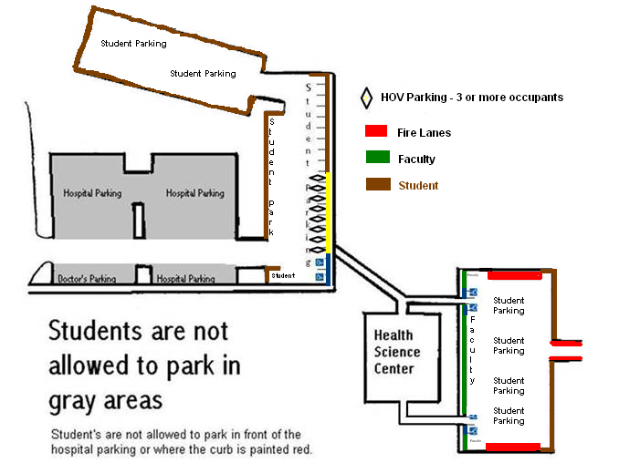

SHUTTLE PARKING AT COUNTRY BIBLE CHURCH:
Park in the areas marked by the blue X’s.

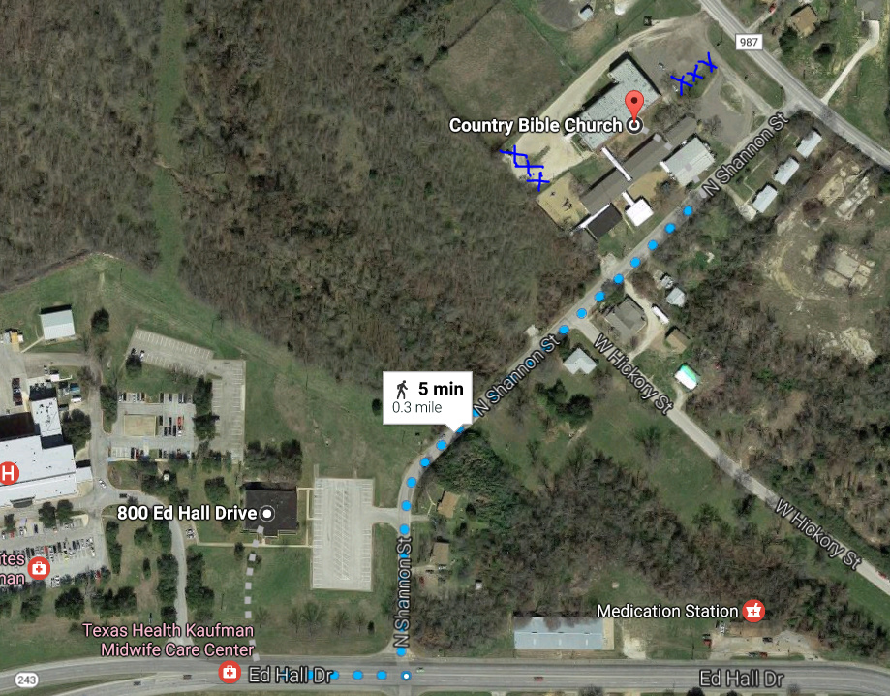

J:Policies/Health Science Center Policies/Rules Revised 03/17

